A Dog and Three Dollars

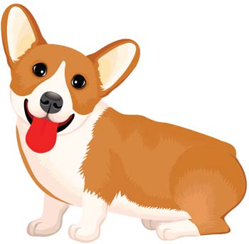
by Mark Twain
I have always believed that a man must be honest. «Never ask for money you have not earned», I always said.
Now I shall tell you a story which will show you how honest I have always been all my life.
A few days ago at my friend’s house I met General Miles. General Miles was a nice man and we became great friends very quickly.
«Did you live in Washington in 1867?» the general asked me.
«Yes, I did,» I answered.
«How could it happen that we did not meet then?» said General Miles.
«General», said I. «We could not meet then. You forget that you were already a great general then, and I was a poor young writer whom nobody knew and whose books nobody read. You do not remember me, I thought, but we met once in Washington at that time.»
I remember it very well. I was poor then and very often I did not have money even for my bread. I had a friend. He was a poor writer too. We lived together. We did everything together: worked, read books, went for walks together. And when we were hungry, we were both hungry. Once we were in need of three dollars. I don’t remember why we needed these three dollars so much, but I remember well that we had to have the money by the evening.
«We must get these three dollars,» said my friend. «I shall try to get the money, but you must also try.»
I went out of the house, but I did not know where to go and how to get the three dollars. For an hour I was walking along the streets of Washington and was very tired. At last I came to a big hotel. «I shall go in and have a rest,» I thought.
I went into the hall of the hotel and sat down on a sofa. I was sitting there when a beautiful small dog ran into the hall. It was looking for somebody. The dog was nice and I had nothing to do, so I called it and began to play with it.
I was playing with the dog, when a man came into the hall. He wore a beautiful uniform and I knew at once that he was General Miles. I knew him by his pictures in the newspapers. «What a beautiful dog!» said he. «Is it your dog?»
I did not have time to answer him when he said, «Do you want to sell it?»
«Three dollars», I answered at once.
«Three dollars?» he asked. «But that is very little. I can give you fifty dollars for it.»
«No, no. I only want three dollars.»
«Well, it is your dog. If you want three dollars for it, I shall be glad to buy your dog.»
General Miles paid me three dollars, took the dog and went up to his room.
Ten minutes later an old man came into the hall. He looked round the hall. I could see that he was looking for something.
«Are you looking for a dog, sir?» I asked.
«Oh, yes! Have you seen it?» said the man.
«Your dog was here a few minutes ago and I saw how it went away with a man,» I said. «If you want, I shall try to find it for you.»
The man was very happy and asked me to help him.
«I shall be glad to help you, but it will take some of my time and…»
«I am ready to pay you for your time,» cried the man. «How much do you want for it?»
«Three dollars,» answered I.
«Three dollars?» said the man. «But it is a very good dog. I shall pay you ten dollars if you find it for me.»
«No sir, I want three dollars and not a dollar more,» said I.
Then I went up to General Miles’s room. The General was playing with his new dog.» I came here to take the dog back», said I.
«But it is not your dog now — I have bought it. I have paid you three dollars for it,» said the General.
«I shall give you back your three dollars, but I must take the dog back», answered I. «But you have sold it to me, it is my dog now.»
«I could not sell it to you, sir, because it was not my dog.»
«Still you have sold it to me for three dollars.» «How could I sell it to you when it was not my dog? You asked me how much I wanted for the dog, and I said that I wanted three dollars. But I never told you that it was my dog.»
General Miles was very angry now.
«Give me back my three dollars and take the dog,» he shouted. When I brought the dog back to its master, he was very happy and paid me three dollars with joy. I was happy too because I had the money, and I felt I earned it.
Now you can see why I say that honesty is the best policy and that a man must never take anything that he has not earned.

